**User manual**

Once login Jupiter Hub.

For installing the Packages please refer to the below user manual.



The Folder structure for the Tape Initiative.

Click on icon  to create a new folder

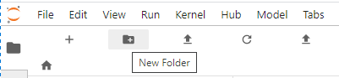

Rename the folder to “Data” Drop all the input files i.e. xlsx to this location with the name “Incident*.xlsx”

Create a new folder and name it as “Regexoutput”

Upload filess Viz.py,stopwords.txt and ApplicationNames.csv using upload files.

Upload Files in Jupiter hub

Click on icon  to upload files and select the file and click open

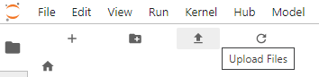

Open terminal.

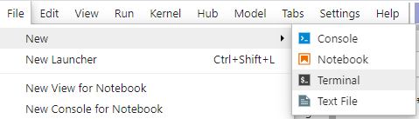

Run below command

python XXX.py and press enter key

topic_model.py (Topic model o/p), app_name_predict.py(Predict the Application Name)

s

After completion we get sh-4.2$

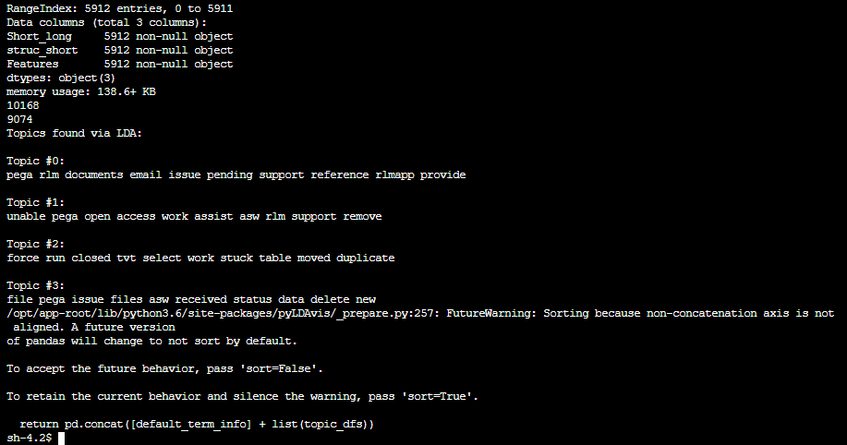

See the file generated ldavis_prepared_4.html, lda_gensim.csv

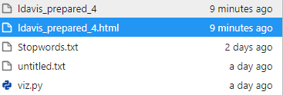s

Right click and download

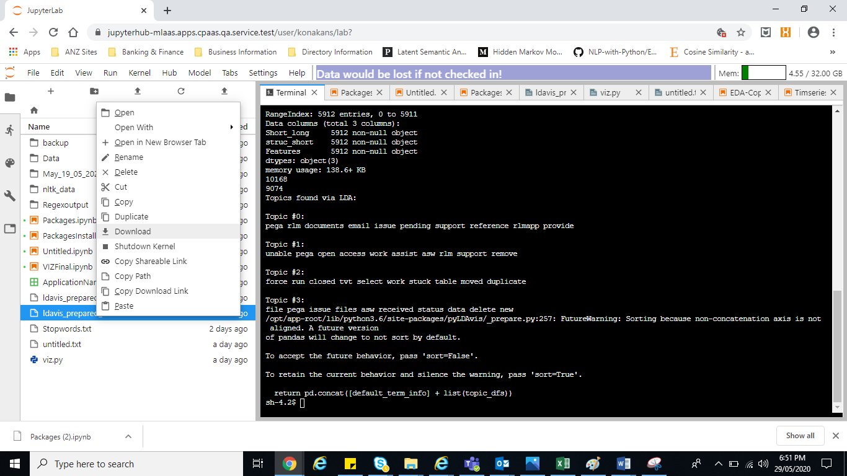Html file open in browser

